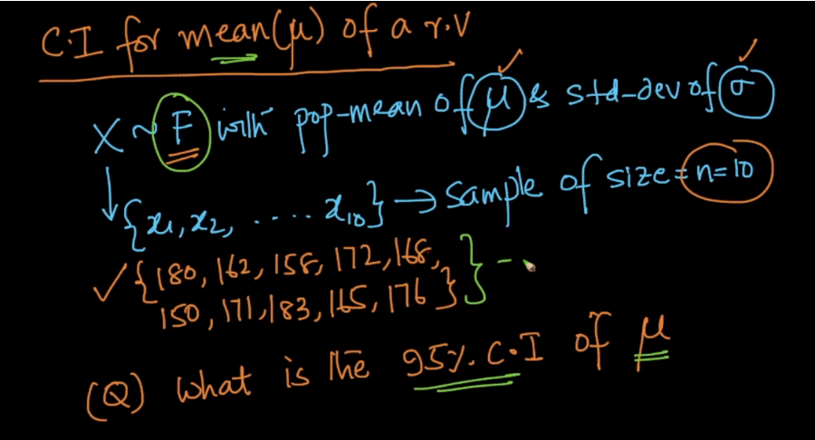

Given a RV which may follow any distribution with mean and SD, and we have to find what is the 95% C.I. of mean.

**Case 1:**

* We’ll take several samples of population and then find the sample mean of each samples.
* Now according to CLT we know that the distribution of sample mean is gaussian distribution with:

Mean = mean of population

S.D. = S.D. of population / square root of n, where n is size of samples.

* Since the sample mean follows the guassian distribution, hence using 64-95-97 rule we can say that 95% of mean will be between

( mean – 2 * S.D of pop / square root of n ) and ( mean + 2 * S.D / square root of n )

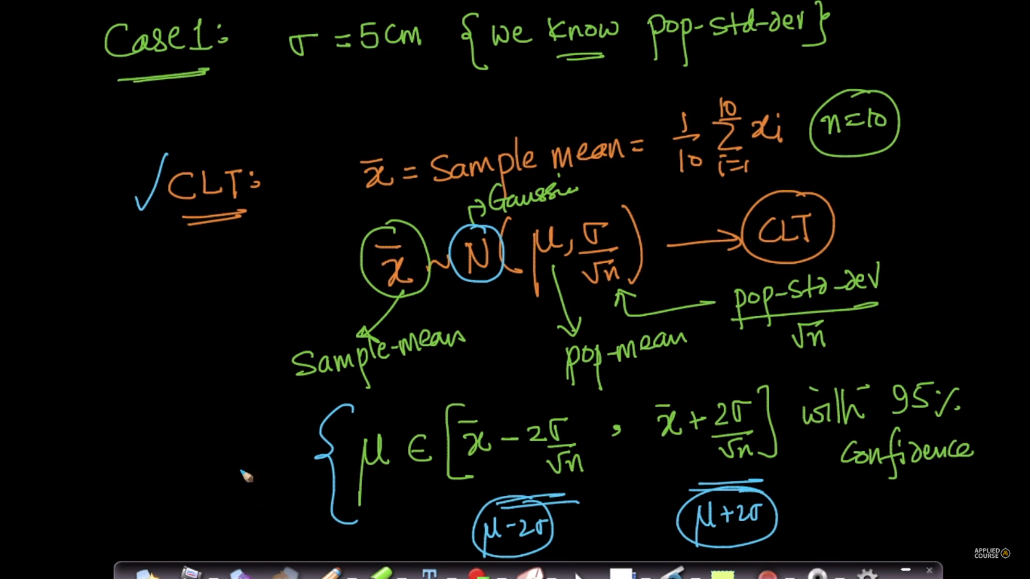

**Case 2:**

What if we don’t know the S.D. of population, then in this case we can use t-distribution to find the C.I. of mean.

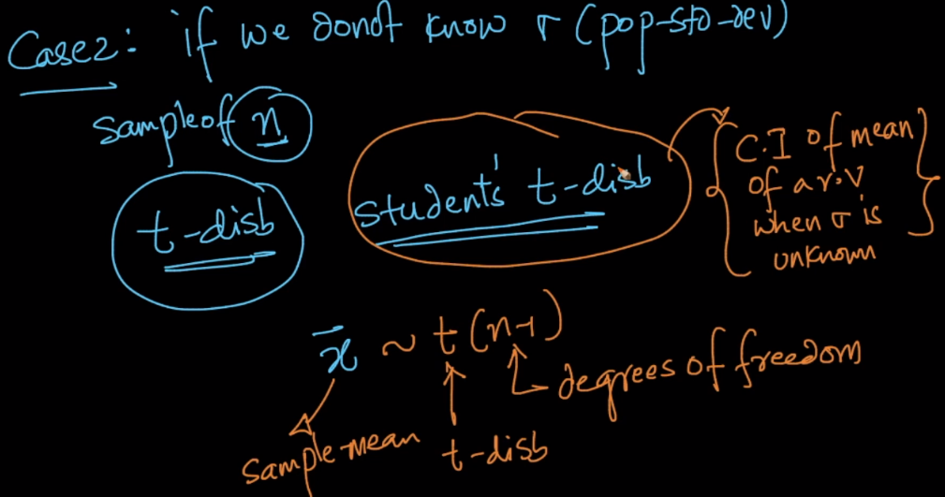

So till now, we only knew how to calculate confidence interval for mean, but how we can calculate CI for other statistics like Median, SD, variance etc. to calculate CI for other statistics we use bootstrapping method.